Note: given the fact that you’re ‘obliged’ to answer the weekly questions, try to profit the most from the task:
- Start by reading the lecture notes.
- Looking at them as little as possible, answer the questions.
The answers of Week 7’s questions should be handed to me at the beginning of Thursday’s lecture of 20th April. The students who are going to have the test of Macroeconomics and Monetary Theory should only hand me the questions at the beginning of Thursday’s lecture of 27th April. They should be manuscript (not typewritten) and preferably based on schemes (as I do in the whiteboard). Keep a copy for yourself.
Please write WEEK 7 in bold at the beginning of your answers.
Week 7 Unconventional MP
1.Explain the meaning of the following sentence: unconventional MP is to be used when CB’s interest rates have been lowered to zero and yet AD remains below FE.

2.Suppose that there are only B1 and B2, and that the Fed sets i1.
a) Which is the risk run by the government and corporations when they fund themselves though two successive B1? Explain.
b) Which is the risk run by banks when they purchases B2? Explain.

3. Why does the B2^{d} curve have a positive slope?

4.a) Why is the B2^{s} curve vertical at a certain moment in time?
b) In this graph, present the effect of the purchase of $600b of B2 by the Fed.
c) What is the effect on p2 and i2? Explain. Is that what happened as a result of the QE in the first half of 2011?
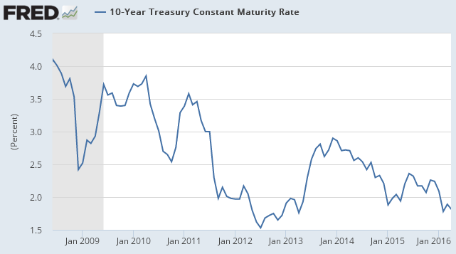
d) How do the less risk averse banks react to that? Exaplain.
e) What is then the effect of the QE on the amount of reserves, B1 and B2 held by banks and by the Fed? Is that what happened as a result of the QE in the first half of 2011?

US:
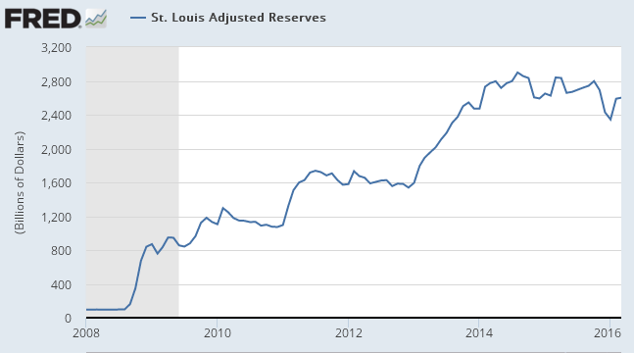
f) If the demand for credit to fund C and I is inelastic with respect to i2, what happens to the amount of credit granted to households and businesses? And to the money stock, AD and U? Explain.

5. What is forward guidance?

6. a)Explain the mechanisms through which forward guidance may reduce U and increase inflation.
b) Explain the mechanisms through which QE may reduce U and increase inflation.

ECB’s QE
7. Describe the main features of the current ECB’s QE.
8. What is the effect of the ECB’s purchases of a country’s public debt on the interest payments of the government of that country:
- Since p 2017? Explain
- From jan 2015 to Mar 2017? Explain.
9. Banks’ profits fall as a result of the ECB’s QE. Why?
10. The predicted efect of the ECB’s QE on i10 has materialized? Consider as tuypical the caase of France:
